**PROJECT DESIGN PHASE-II**

**CUSTOMER JOURNEY MAP**

|  |  |
| --- | --- |
| DATE | 15 October 2022 |
| TEAMID | PNT2022TMID47699 |
| PROJECT NAME | Project – Intelligent Vehicle Damage Assessment and Cost Estimator for Insurance Companies |
| MAXIMUM MARKS | 4 marks |

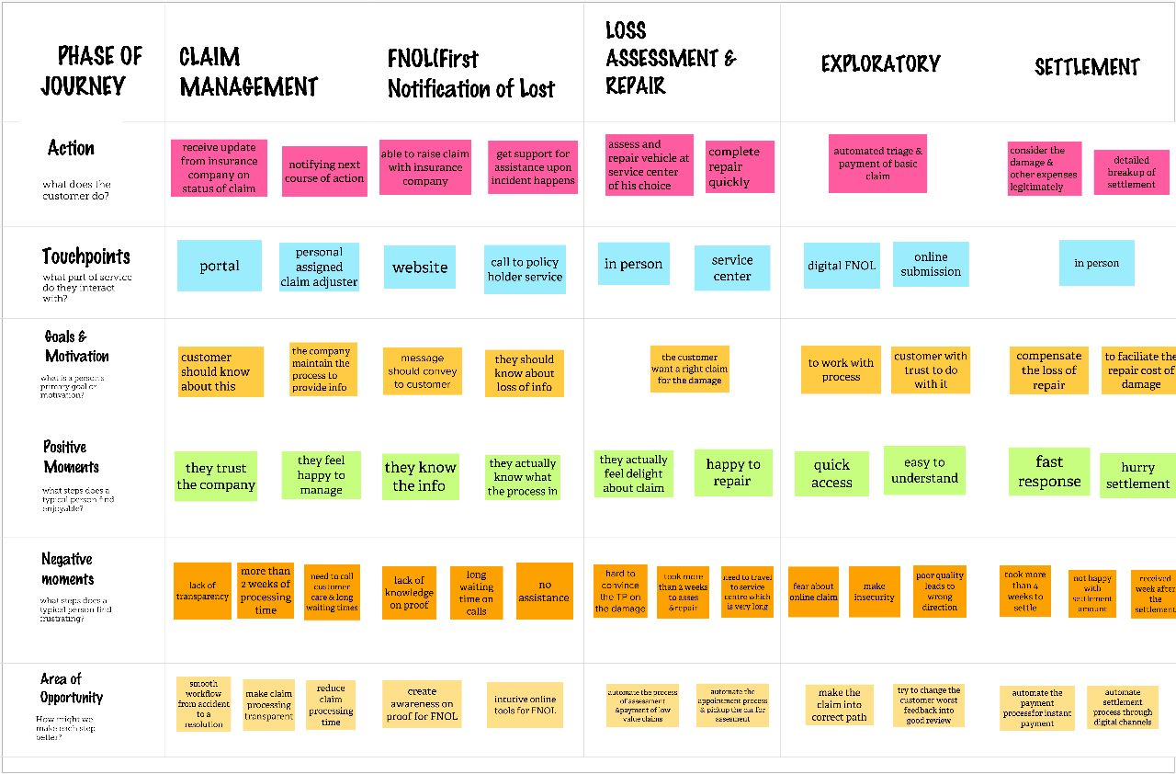

**CUSTOMER JOURNEY:**